 | SOAR COMMUNITY  JOB DESCRIPTION
POST TITLE
Lead Social Prescribing Link Worker
SERVICE FUNCTION
Triage, assessment & co-ordination (refer to appendix 1)
GRADE
Salary: SP14 £26,424 – SP18 £28,101 (dependant on experience & qualifications)
RESPONSIBLE TO
Guy Weston – Health Services Manager
Helen Clark – Deputy Network Manager
RESPONSIBLE FOR
Social Prescribing Link Worker(s)
KEY TERMS & CONDITIONS
37 hours per week
25 days annual leave & Bank holidays (also additional birthday leave)
8% non-contributory pension
Direct clinical supervision provided
Reflective practice sessions provided
Permanent subject to funding

Other key benefits:
- SOAR is a living wage employer and seeks to uprate salaries by the annual increase in the National Living Wage Foundation
- Cycle to work scheme – Buy a bike tax free and cycle to work
- Westfield Foresight Health Plan – Annual benefits and services such as routine dental work and check-ups, etc.

PURPOSE OF JOB
The Lead Social Prescribing Link Worker (SPLW) will oversee the day to day running of the SPLW team. Taking a lead on the operational delivery, management and development of the SPLW service. The role will work as part of SAPA5 Primary Care Networks multi-disciplinary team enabling clients to access a range of services and activities that positively impact on their wellbeing and build connections within their community. The role will:
- Act as a single point of access for referrals from Primary Care Network staff and partner organisations into local and city-wide services & activities (the Social Prescribing System)
- Undertake an initial client ‘triage and assessment’ that enable the appropriate service to be put in place at the right time, based on the clients’ needs and wishes
- Co-produce a personalised support plan that encourages empowerment of an individual to take control of their own health and wellbeing (‘what matters to me’)
- Bring in ‘bridging’ support that enables an individual to access services that aren’t in place or complex to navigate, ensuring follow up referrals take place

- Develop a comprehensive knowledge of wider support services for individuals with varying support needs, developing and implementing referral pathways where appropriate

- Undertake line management of staff

- Work in partnership with clinical and non-clinical staff that form part of the PCNs Personalised Care Team
- Develop close working partnerships with health, social care, housing and voluntary, community or social enterprise (VCSE) sectors.

Overview – SAPA5 PCN Requirements
The working area covers a large neighbourhood across north east Sheffield.

Delivery will be focussed on patients aged 18+ and registered with a SAPA5 GP surgery:
- Barnsley Road Surgery
- Buchanan Road Surgery
- Elm Lane Surgery
- Green Cross Group Practice
- Norwood Medical Centre
- Shiregreen Medical Centre.

The Lead SPLW should be seen as a ‘yellow pages’ for the client, someone who is up to date on what services are available and how best to access them or who to contact. Essentially, increasing uptake of support and access to resources for the client.

The role will be non-clinical in nature. It will involve undertaking holistic reviews of clients whom many have complex social and health needs which affect their wellbeing. Example. Poor access to quality housing, mental health issues, lack of physical activity uptake, long term conditions, social isolation, etc.

The Lead SPLW will work in partnership with the PCNs clinical & non-clinical staff to develop a multi-disciplinary approach to addressing ill health within the network.

Training
The Lead SPLW will be provided with a full induction programme and package of accredited/non-accredited training, including:
- Health Coaching up to intermediate level
- Personalised Care Institute/E-LFH modules
- Online seminars via NHSE Regional Social Prescribing Link Worker learner platform
- Professional shadowing
- Mental Health First Aid (MHFA)
- Mandatory training, includes; Safeguarding, Health & Safety, Data Protection (GDPR) and Equality & Diversity (EDI).
SAPA5 PCN will provide:
- Induction covering personalised care roles, and introduction to GP surgeries
- Clinical system training (SystmOne/Emis) either through SY-ICB and/or GP Surgery
- Working with interpreters & use of telephone-based system(s)
- Other professional development opportunities or mandatory training as would be offered to associated primary care workforce, i.e. CPR, etc.

Location
Clinical Base
The Lead SPLW will be primarily based out of the network GP surgeries to engage clients, update clinical systems and engage with wider practice team colleagues.
Note. A point of contact will be provided at each surgery where the role is based.

Administrative Base
The Lead SPLW will spend time at SOAR sites for operational, administrative, management purposes and to engage wider SOAR colleagues. Site(s):
- Learning Zone, 320 Wordsworth Avenue, Sheffield, S5 8NL
- One Stop Shop, 19 Bellhouse Road, Sheffield S5 6HJ.

SPECIFIC DUTIES AND RESPONSIBILITIES
One to One Delivery
- Act as the single point of access for referrals into the Social Prescribing system from PCN staff and partner organisations, according to the PCN requirements
- Complete an initial ‘triage and assessment’ (includes assessing risk) with the individual, gathering service information and bring in additional professional support/advice when appropriate
- Co-produce a personalised support plan (& amend accordingly) using a person-centred approach to empower the individual to identify the wider issues that are impacting on their own health and wellbeing
- Active signposting (discharge) by connecting clients to activity or service without further support
- Hold a caseload enabling individuals with low support needs to sustain goals/outcomes according to their personalised support plan (up to 1 month), including case coordination, low level form filling and following up appointments - refer to appendix 2
- Where appropriate, introduce the individual to community groups, activities and statutory services, ensuring they are comfortable. Follow up to ensure they are happy, able to engage, included and receiving good support
- Develop a trusting relationship on a one-to-one basis that provides the individual time to explore ‘what matters to them’, either via telephone or face-to-face in various settings including GP practices, home visits and community spaces
- Maintaining comprehensive, regular and effective feedback mechanisms with referring GP practices and other appropriate organisations within the social prescribing system.

Service Development
- Develop a comprehensive knowledge of wider support services for individuals with varying support needs including but not exclusive to; health, housing, employment, welfare benefits
- Work in partnership with Care Coordinators, Wellbeing Coaches and other staff, to ensure effective and responsive referral pathways are maintained as part of the Personalised Care Team offer
- Inform line manager and network manager of ways in which local services can be developed to improve the health and wellbeing of the local community.

Work with Others
- Offer signposting support and guidance to members of the PCN Personalised Care Team and wider network colleagues, i.e. front of house reception teams as appropriate, sharing information on what services are available and how to access them
- Based within participating GP Surgeries and maintain effective relationships with health, social care, housing and VCS workers via regular attendance at team meetings and shadowing
- Attend network MDT meetings (as appropriate) to develop relationships with key services, increasing awareness and knowledge of social prescribing and the impact on reducing pressures through partnership working.
- Work with relevant partners to identify any unmet needs within the community, and share with the PCN and SOAR.

Staff Management
- Manage the day to day running of the SPLW Team; providing advice, development support, motivation and encouragement
- Co-ordinate the work of the SPLWs through use of effective case management procedures
- Provide professional peer support to the SPLWs around complex cases
- Undertake annual staff appraisals and bi-monthly supervisions in partnership with network manager(s)
- To arrange regular team meetings.

Team Working
- To take part in regular team meetings to discuss performance and other related issues
- Have knowledge and understanding of all SOARs Teams and willingness to work across teams to provide support when required.

Self-Management & Development
- Ability to work with minimal supervision within appropriate guidelines
- Ability to make decisions to progress own work within appropriate guidelines
- Ability to manage own workload to ensure maximum performance through planning and organizing, with an understanding of when and how to prioritise referrals requiring urgent support
- To participate in supervisions and appraisal process
- To attend regular clinical supervision
- Undergo continuous personal development as is required.

Monitoring, Report and Evaluation
- Ensure referrals are recorded within GP clinical systems using national SNOMED codes
- Utilise SOARs monitoring & information system as a means of recording activity and outcomes
- Assist in compiling reports as and when required for monitoring & reporting purposes.
- Capture key information and gather feedback on the impact of social prescribing on health and wellbeing
- Follow up on the referral uptake, engagement rates and progress made with external referrals

Compliance
- To adhere to company policies and procedures, including confidentiality, equality & diversity, safeguarding, lone working, information governance and health and safety
- To ensure company records and information are kept confidential at all times and stored securely
- To have regard for resources and use responsibly
- To uphold the Staff and SOAR Services Charter
- To understand the Competency Framework and work using key competencies.

General
- Undertake joint visits within client homes and/or GP Surgeries (as appropriate)
- Alert line manager to any issues of concern including work issues, complaints or concerns regarding individuals
- Any other duties as requested by Managers.
PERSON SPECIFICATION
Post Title: Lead Social Prescribing Link Worker

Minimum Essential Specification | Method of Assessment
 | Application | Interview | Exercise
Skills/Knowledge
Knowledge of the causes of health inequalities
Understanding of the barriers people face to improving their health
Commitment to a person-centred approach when co-ordinating and brokering access to services
Awareness of your own limits of skills, competences and responsibilities and work within them
Knowledge and commitment to current Health & Safety, Adult Safeguarding and Equality and Diversity legislation
Effective case load management skills
Effective time management skills
Effective administrative & IT skills; including knowledge of EMIS/SystmOne/Vision
Experience/Qualifications/Training
Experience of staff/team management, including:
- undertaking staff appraisal/supervision
- identifying staff training needs, etc.
Experience of case management processes and case supervision
Experience the health, social care, housing and voluntary, community or social enterprise (VCSE) sectors
Experience of supporting people to access resources (& remove barriers) within the community
Ability to problem solve and respond quickly and flexibly to new developments and challenges
Ability to communicate effectively both verbally and in writing, with a range of individuals and groups
Ability to maintain client records, monitor activity and record outcomes and learning
Good knowledge of English
Level 3 or 4 Information, advice & guidance qualification (or willing to work towards) and/or equivalent experience, examples:
- health
- social care
- housing, etc

Desirable
Full UK Driving Licence
Own transport
Essential
NA

Appendix 1. Social Prescribing Link Worker Function
To outline Social Prescribing Link Worker function; how they interact with clients and impact on the individual, i.e. levels of activation.

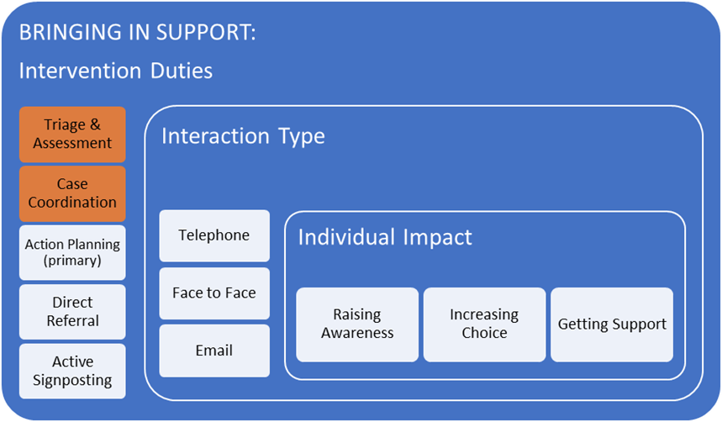

Key:
- Orange – Primary duties to be carried out as per specified role.

Appendix 2. Individual Support Needs
To outline the level of support a client may require based on presenting needs; detailing intervention type, duration and assessment.

Support Need Level | Client Intervention Needs | Client Issues  (multiple) | Client Contact Duration | Client Assessment (client coaching plan)
3.  HIGH | Coaching & practical support. Removing complex structural barriers to ill health. Reactive in nature. | 5+ | 0-6mths+ | Full Assessment
2.  MODERATE | Coaching support. Shaping healthy /economic behaviours & maintaining change. Preventative in nature. | 0-5 | 0-3mths | Full Assessment
1.  LOW* | Case coordination. Enabling access to services that aren’t in place or complex to navigate. Bringing in support. | 0-3 | 0-1mth | Partial Assessment
0. *  ACTIVE SIGNPOSTING | Provision of information. Connecting to an activity or service without support. | NA | NA | NA
Note. *applicable to Social Prescribing Link Worker role

SOAR Community is closed between Christmas & New Year and annual leave must be retained for this period

