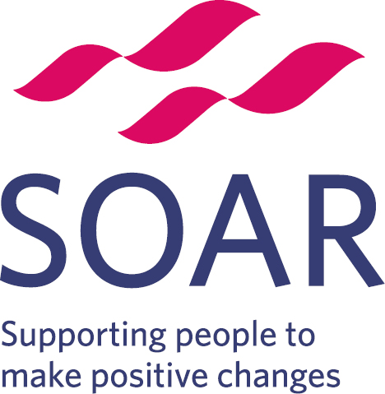 | Volunteer Role Description
Post title: Volunteer Stay and Play group facilitator

Responsible to: Families and Communities Team

Time commitment: Regular attendance at the weekly Burngreave toddler group – time TBD

Purpose of role: The Stay and Play sessions at Burngreave Library are aimed at families with young children and toddlers, from pregnancy to 5 years old and usually last for 90 minutes. They are free, relaxed spaces for meeting like-minded parents, grandparents, childminders and other carers, supported by the Families and Community Services team

Location: Burngreave Library, 42 Spital Hill, Sheffield S4 7LG

Travel Information: - Served by a number of buses from Sheffield City centre including 1, 1a, 2, 5, 20, 32, 47, 48, 76, 88, 97, 98

Parking is available on the roads around the library at no cost, but is likely to involve a walk of at least 5 mins.

Accessible parking is available at Sorby House for Blue Badge holders. Please contact us or the Sorby Facilities team (0114 400 0340) for details.

What’s involved?
The role of the Volunteer ‘Stay and Play’ group facilitator is:
- Setting out toys and games for the children to play with
- Welcoming parents/carers and their families to make friends and feel supported
- Encouraging parents with different types of play with their children
- Clearing up any mess and spills as they occur
- Offering parents hot and cold drinks and preparing the children’s snack
- Clearing up and tidying away
- Maintain the register of attendance
- Collect contributions from attendees
- Complete registration forms with attendees
- Providing a safe and happy environment for children to play, learn and interact
- Being the basis for developing long-lasting relationships for young families looking for friendship and support
- Being an extended family to those that attend
- Making a valuable contribution to community life
- Signposting parents/guardians to resources to assist them in providing happy and healthy lives for their families
- Working with parents/guardians to plan activities for the group

What knowledge do I need?
As a Volunteer ‘Stay and Play’ group facilitator, it would be beneficial for you to know about
- Providing a safe, stimulating group play to meet the social, linguistic, creative, physical, imaginative, emotional needs of each child
- How to encourage and enable parental involvement in the group
- Keeping up to date records
- Providing and maintaining equality of opportunity for all children and their families.
- Establishing productive working relationships with children, acting as a role model and setting high expectations.

What skills do I need?
As a Volunteer ‘Stay and Play’ group facilitator, we ask that you:
- Have a friendly and approachable manner
- Have the ability to be part of a team
- Have a proactive and professional attitude
- Understand the importance of confidentiality
- Communicate sensitively with parents/carers and their children
- Have good spoken and written English skills
- Are enthusiastic, committed, trustworthy and reliable
- Are supportive and non-judgmental

What can I gain from this role?
- Experience and confidence within a professional setting
- Developing knowledge around Child & Family Support
- An excellent opportunity to develop new and existing transferable skills
- Improving your CV and employability
- Leadership experience
- A sense of fulfilment in affecting positive change in the lives of parents/carers
- Making a real contribution to supporting parents/carers and in turn their children within the local community
- Being part of a friendly and dedicated team that supports a diverse community

Benefits
- Training - You will receive an induction and mandatory training on topics relating to your role. You will also receive a handbook and have access to policies and procedures, including Health & Safety and Safeguarding.
- Access to our standard e-learning package, giving you a great basic introduction to topics such as Safeguarding and Equality and Diversity.
- Face-to-face training to ensure that you are fully equipped with the knowledge and skills needed for this role
- Regular meetings with your supervisor to discuss any challenges you are facing and celebrate your progress in the role
- Ongoing support from your supervisor and the wider team.

Recruitment Process
Individuals interested in the role will be required to complete an application form and have an initial chat with a Community Development Worker at SOAR.

Development
Expansion of personal networks, connection to community job clubs, and support from your volunteering supervisor in personal and professional development.

Support
You will be supported by a dedicated member of staff who will ensure that training and development needs are met during your time with SOAR, and provide ongoing support and supervision as needed.

Expenses
We will refund you for any reasonable expenses, such as travel and activity costs.

DBS Checks
A DBS check will be required for this role. Your supervisor will go through this with you before you start. We are still required to ask for two references for all roles.

For more information, please email: dominique.dowde@soarcommunity.org.uk or call 0114 213 2591 or 07507798054

