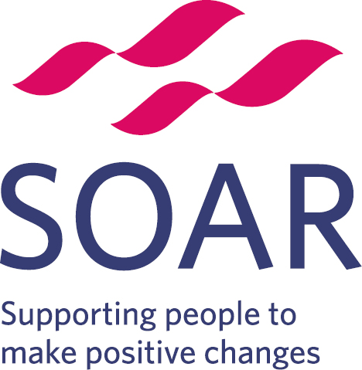 | Volunteer Role Description
Post title: Library Development Volunteer

Responsible to : Families and Communities Team

Time commitment: Variable

Purpose of role: Burngreave Library is so much more than just books. We run activities for adults and children and special events for the local communities. We are looking for dedicated volunteers who can help develop these activities to make Burngreave Library the best it can be.

Location: Burngreave Library, 42 Spital Hill, Sheffield S4 7LG

Transport: Served by a number of buses from Sheffield City centre including 1, 1a, 2, 5, 20, 32, 47, 48, 76, 88, 97, 98
Parking is available on the roads around the library at no cost

What’s involved?
The role of the Library Development Volunteer is very flexible, and what you do will be very dependent on what you are passionate about or interested in. Some of the things you may be required to do include:
- Working with other library volunteers to determine what is needed in the library
- Talking to members of the public using the library to find out what they would like to see in the library
- Researching events and activities at other volunteer-led libraries
- Developing new groups in the library (e.g., homework club or conversation group)
- Reaching out to local community organisations to encourage their use of the library space
- Working with SOAR staff, other library volunteers and community members to help make Burngreave Library a vibrant and active community space
- Updating notice boards and leaflets
- Liaising with other libraries
- Other ad hoc library duties as and when required

What skills do I need?
As a Library Development Volunteer, we ask that you:
- Are passionate about libraries and communities
- Have good customer service skills
- Have good communication skills (written and verbal)
- Have good IT skills, or are willing to develop your current skills
- Have good interpersonal and team working skills
- Are able to respect confidentiality
- Are respectful and supportive of people regardless of background
- Can research information to use to help people
- Are friendly, enthusiastic, reliable and committed

What can I gain from this role?
- Develop transferable skills
- Enhance your CV
- Valuable experience in community-based work
- A greater awareness of services and activities in your local area
- Many training opportunities, which can include, but are not limited to areas such as Library Management System, Safeguarding and Data Protection
- Opportunity to meet new people and develop your social skills
- Access to SOAR’s training and employment services

Training
All SOAR volunteers receive SOAR induction training and some basic health and safety training. You will also receive a volunteer handbook and have access to policies and procedures, including health and safety and safeguarding.

Further training is available for your role and may include:
- Sheffield City Council Volunteer Library Induction Training (optional)
- First Aid (optional)
- Safeguarding (essential depending on role)

Recruitment Process
Individuals interested in the role will be required to complete an application form and have an initial chat with a member of the Community Development Team at SOAR.

Development
This could include expansion of personal networks, connection to community job clubs, and support from your volunteering supervisor in personal and professional development.

Support
You will be supported by a dedicated member of staff who will ensure that training and development needs are met during your time with SOAR, and provide ongoing support and supervision as needed.

Expenses
We will refund you for any reasonable expenses, such as travel and activity costs.

DBS Checks
A DBS check may be required for this role. Your supervisor will go through this with you before you start. We are required to ask for two references for all roles.

For more information, please email: communities@soarcommunity.org.uk or call us on: 0114 213 4120

